Project Summary:

american Gun violence in 2017

## By: Alicia saracina, amgad farah, faisal sabbir

# In which state is gun violence the highest?

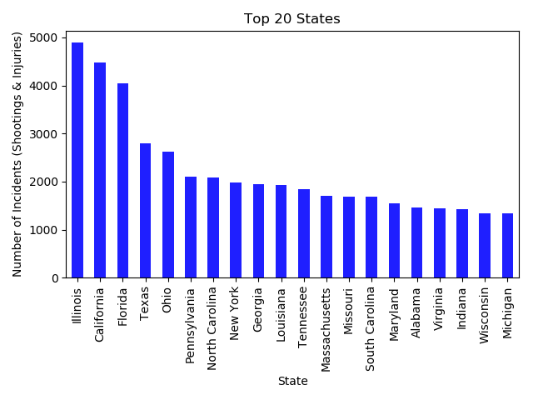In 2017, the highest state with gun violence by total count was Illinois. The following states (in order) are: California (4,588), Florida (4,156), Texas (2,875), Ohio (2,701), Pennsylvania (2,172), and North Carolina (2,141).

# in which city is gun violence the highest?

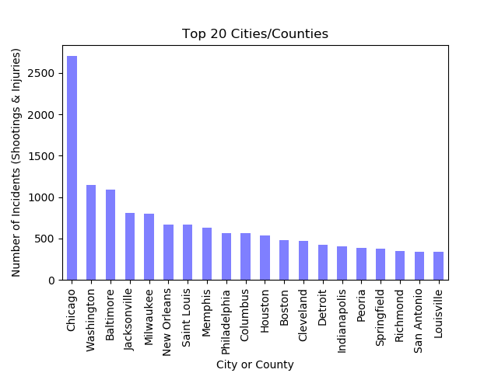In 2017, the highest city with gun violence by total count was Chicago (2,812). The following cities or counties (in order) are: Washington (1,171), Baltimore (1,113), Jacksonville (827), Milwaukee (815), New Orleans (689), Saint Louis (672).

# Does gun violence rise during different times of the year?

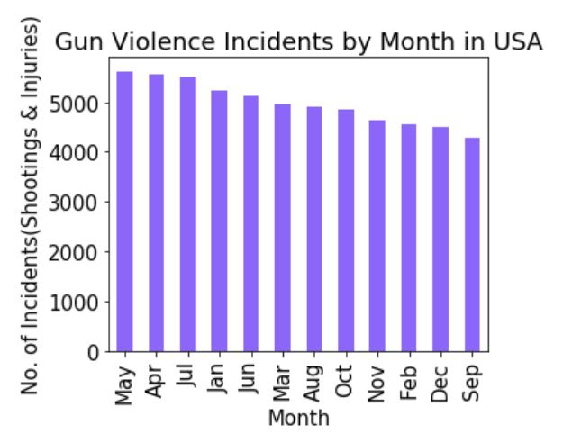Gun violence was at its highest during the month of May. The following months (in order) are: April, July, January, June, March, August, October, November, February, December, September.

# How many guns are involved per incident?

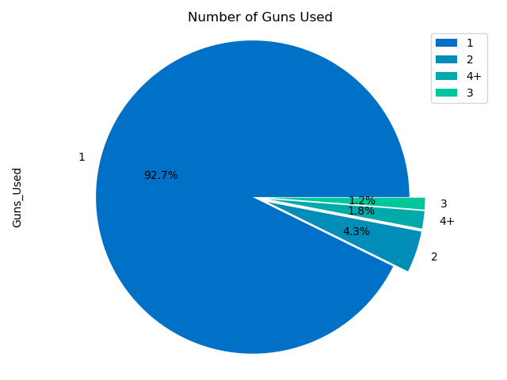The vast majority of incidents involve only one gun. Seven states reported that 50 guns were used in some instances, the maximum valued reported in this category.